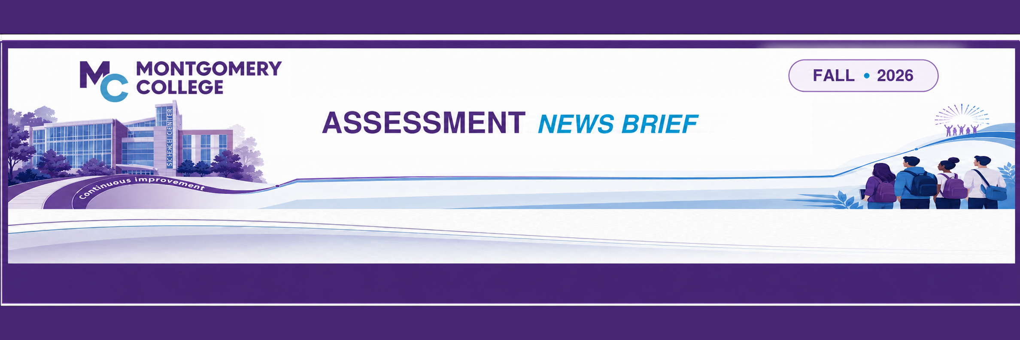
NEW ASSESSMENT TECHNOLOGY
Montgomery College recently transitioned to a full suite of Watermark products for all assessment activities, including General Education Assessment and CAR. Here are a few workshops that provide a general overview of the products. Presented by Debbie Grubb:

SESSION | DATE & TIME | MEETING LINK
Scoring for General Education in Watermark | Wednesday, Oct. 28, 2:00–3:00 p.m. | Register for Zoom Session
Scoring for General Education in Watermark | Monday, Nov. 2, 12:00–1:00 p.m. | Register for Zoom Session
Scoring for General Education in Watermark | Thursday, Nov. 12, 4:00–5:00 p.m. | Register for Zoom Session
SESSION | DATE & TIME | MEETING LINK
Watermark Intro for Chairs/Coordinators | Tuesday, Oct. 27, 10:00–11:00 a.m. | Register for Zoom Session
Watermark Intro for Chairs/Coordinators | Friday, Nov. 13, 3:00–4:00 p.m. | Register for Zoom Session
Need a different session for a specialized group? Contact Debbie Grubb: deborah.grubb@montgomerycollege.edu

UPDATED DATA RESOURCES  The CAR Data Dashboard has been updated to include course enrollments. Attend a session by Scott Poese from OIRE to discover how to navigate this tool:  Let's Talk Data (LTD) – CAR Dashboard  Presented by Scott Poese (OIRE)  - Date: Thursday, Oct. 22  - Time: 10:00-11:00 a.m.  - Meeting: Join Zoom Link | ANNUAL UPDATE CHANGES  The process for submitting Annual Update Reports is currently being revised to facilitate a more user-friendly and efficient method for completion. Faculty will no longer be required to initiate the report themselves during years 1, 2, 4 & 5. Instead, a survey link will be sent out by the Office of Assessment to any corresponding disciplines/programs that are due to submit the report approximately a week before the due date (October 1) of each year. Once received, a short report survey will be able to be completed and submitted directly from the link that they receive in their email. Changes will take effect during the 2026-2027 reporting cycle.

ADDITIONAL WORKSHOPS | DETAILS
Managing Your Assessment Schedule | These sessions are designed to provide information to disciplines and programs to help manage assessment activities.  Wednesday, November 4 Join Zoom Link  11:30 a.m. - 12:30 p.m.
CAR Checkup | Designed for programs and disciplines currently working on their CAR reports.  Wednesday, November 11 Join Zoom Link  3:00 p.m. – 4:00 p.m.

WHAT’S DUE SOON? | FALL 2026 | FALL 2027
CAR Reports | Anthropology, Music, Criminal Justice, Philosophy, Education, Psychology, General Education, Sociology, General Studies, Women's/Gender Studies | Biology, Chemistry, English, Emergency Prep Management, Fire Science, Health Information Management, Medical Sonography, Nursing, Physical Therapy Assistant, Physics, Radiological Technology, Surgical Technology
Year 3 Reports | Accounting, History, Business Administration, Hospitality, Computer Applications, International Studies, Computer Gaming/Simulation, Management, Computer Science, Network/Wireless Technology, Cybersecurity, Nutrition, Economics, Paralegal Studies, Engineering Science, Political Science, Ethnic Social Studies | Art, Broadcast Media, Communication Studies, Dance, ELAP, Film, Graphic Design, Interior Design, Honors Program, Learning Centers, Linguistics, Mathematics, Performing Arts, Photography, Scholars Programs
QUESTIONS? CONTACT THE OFFICE OF ASSESSMENT: outcomes@montgomerycollege.edu

